Option #2: Image Dataset Augmentation

Edmond Tucker
Colorado State University Global
CSC525: Principles of Machine Learning
Dong Nguyen, Dr.
21 April 2024

Option #2: Image Dataset Augmentation
This Python script is designed for augmenting image datasets, such as the provided and shortened MRI brain scans (Darabi, 2024). Developing machine learning models, which often utilize millions or even billions of parameters, they require a large number of diverse training examples. Due to the difficulty in gaining such large amounts of image dataset for a specific models use, such as brain scans, a practical solution is artificially augmenting the existing dataset.
Methodology
The script enhances the robustness and diversity of a dataset through several augmentation techniques, aiming to train neural networks that can maintain invariance. Invariance of a model, such as an image classification neural network, seeks to correctly classify objects regardless of their orientation, size, or illumination variations. These attributes are crucial for applications like tumor detection in MRI scans, where accurate diagnosis must not be hindered by such differences. The augmentation script can be used on any images set within the same folder however and is useful in many computer vision activities.
Augmentations Implemented
- Initialization and Saving Originals: It loads each image, converts it to RGB color space for uniformity and saves a copy of the original image next to its new counterparts.
- Rotations: The script performs rotations on the image at 90, 180, and 270 degrees, saving each rotated version. This can help the model learn from different orientations.
- Flipping: Both horizontal and vertical flips of the image are created and saved. Flipping images is another way to view different angles or orientations of the object.
- Color Inversion: The script inverts the colors of the image. This type of augmentation can be particularly useful in highlighting different features within the images.
- Brightness Adjustment: It adjusts the brightness of the image by increasing the beta value (brightness bias). Two levels of increased brightness are saved but any number can be assigned within the script.
- Contrast Adjustment: Contrast is adjusted by altering the alpha value, with two levels of contrast enhancements saved and any number of additional levels available within the script. Higher contrast can help in distinguishing subtle differences in imagery.
- Noise Addition: Random noise is added to the image. Making the model more robust to variations and noise in new, unseen images and their potential imperfections (Shorten, 2018).
- Directory Management: The script creates necessary directories to save these augmented images, organizing them by their original names in new subfolders for organization and quick reference. This helps in maintaining a structured dataset for training and validation.
Organization and Efficiency
Not only does the script efficiently manage the creation and storage of these augmented images, but it also organizes them into specific directories per original image, ensuring that the dataset is both expanded and systematically arranged for easy access during model training.
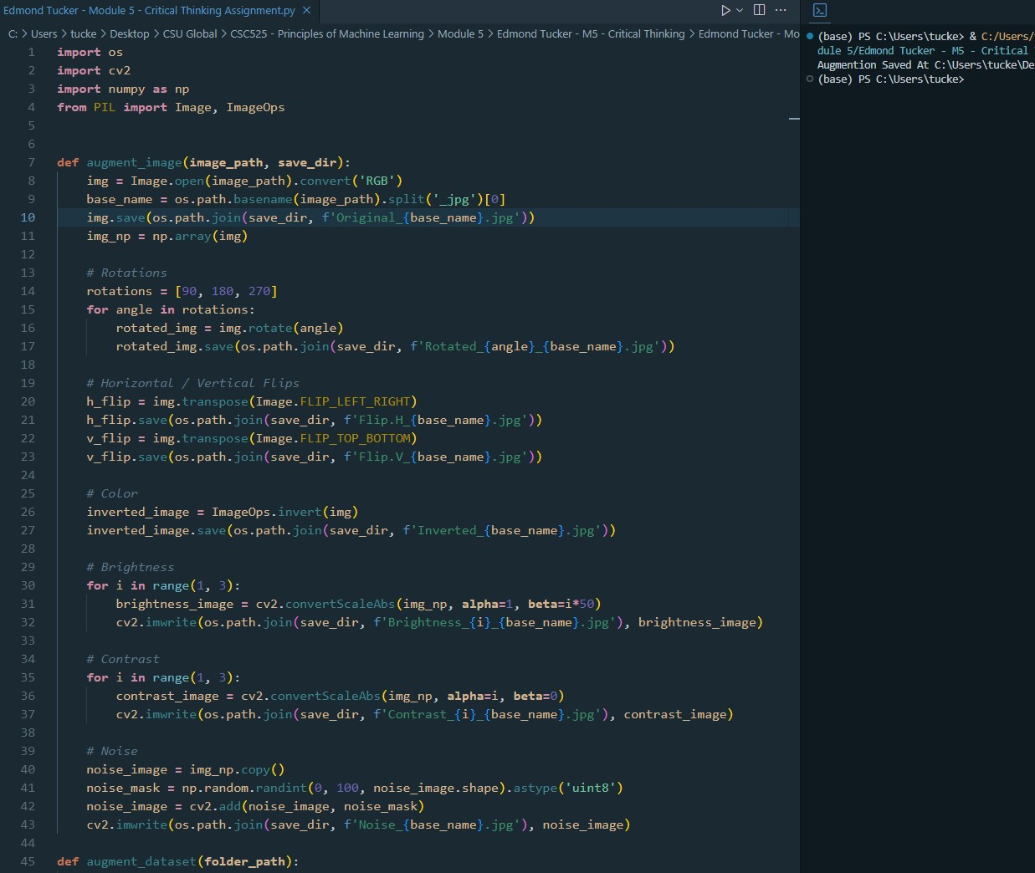
Conclusion
By artificially creating these variations, the script alleviates the need for a larger set of real images, addressing the scalability issues inherent in training sophisticated neural networks.
This method not only maximizes the utility of available images but also prepares the model to handle any other image datasets placed within the parent folder.

References
Darabi, P. (2024). Medical Image DataSet: Brain tumor detection. Kaggle. https://www.kaggle.com/datasets/pkdarabi/medical-image-dataset-brain-tumor-detection
Shorten, C. (2018). Image augmentation Examples in Python - towards Data Science. Medium. https://towardsdatascience.com/image-augmentation-examples-in-python-d552c26f2873

